**CS 207: Applied Database Practicum**

**In-Class Activity 6: Introduction to Stored Functions, Cursors and Triggers, 17th September, 2018**

In this activity, you will be working in Mysql.

Q1. In this question load the database from the dump file (join.sql) given in moodle

The Database has the following tables:

Customers: stores customer’s data.

Products: stores a list of scale model cars.

ProductLines: stores a list of product line categories.

Orders: stores sales orders placed by customers.

OrderDetails: stores sales order line items for each sales order.

Payments: stores payments made by customers based on their accounts.

Employees: stores all employee information as well as the organization structure such as who reports to whom.

Offices: stores sales office data.

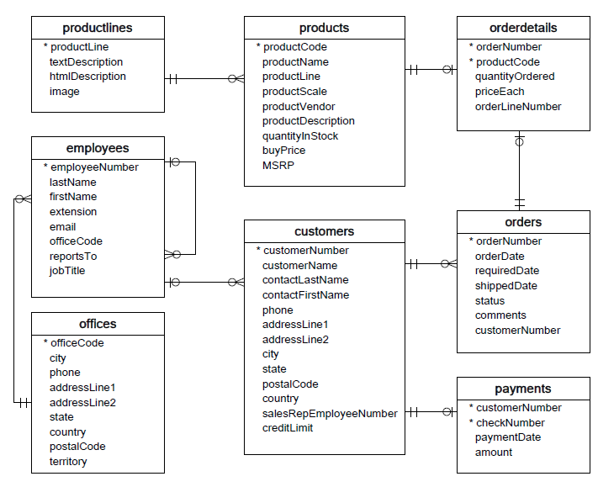

Q1. Create a stored function that takes as input the creditlimit of a customer from the **customers** table and assigns the following CustomerLevel to each customer:

i) if creditLimit > 50000 then assign CustomerLevel=**PLATINUM**

ii)if creditLimit <=50000 and creditLimit >=10000 then assign CustomerLevel=**GOLD**

iii) if creditLimit <=50000 then assign CustomerLevel=**SILVER**

**The output should be something similar to the image below**

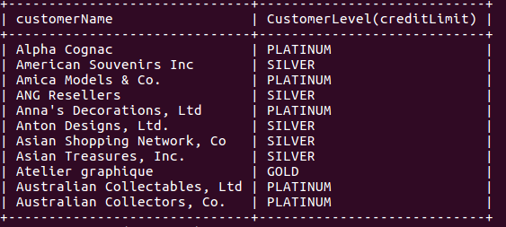

Q2. Create a table temp with the following schema:

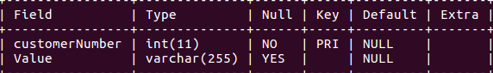

Create a stored procedure containing a cursor that

i) Fetches the customerNumber and creditLimit from **customers** table

ii) Fetches the customerNumber and Total amount paid by each customer from **payments** table

iii) If the Total amount > creditLimit then insert into the **temp** the customerNumber and “**limit exceeded**”

iv) If the Total amount < creditLimit then insert into the **temp** the customerNumber and “**below limit**”.

**The output should be something similar to the image below**

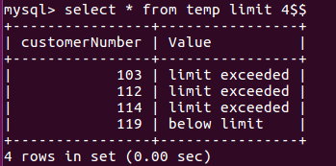

BONUS: ONLY if you have done the above steps, then you can try this bonus for an extra point.

Q3. Create a table **payments_copy** having exactly the same schema as the table **payments (The schema is given below)**

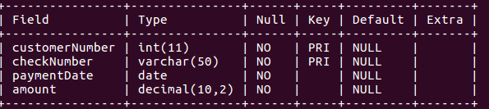

Copy the contents of the table **payments** into the table **payments_copy.**